Name__________________________________________Date___________________
Part I: Look at this list of words. After 2 minutes, turn your paper over write down the words you remember.
Table Car Tulip
Carrots Apple Pen
Hamburger Palm Tree Bus
Elephant Banana Horse
Shoes Clouds Hotel
Part II: Look at this list of words with pictures. After 2 minutes, turn your paper over and write down the words you remember.
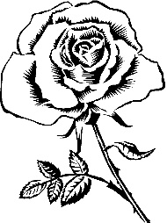 | 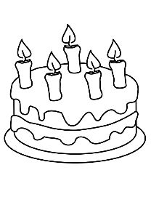 |  |  | 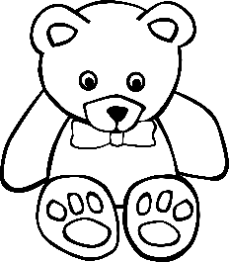
Rose | Birthday Cake | Dog | Grapes | Teddy Bear
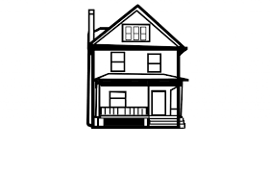 | 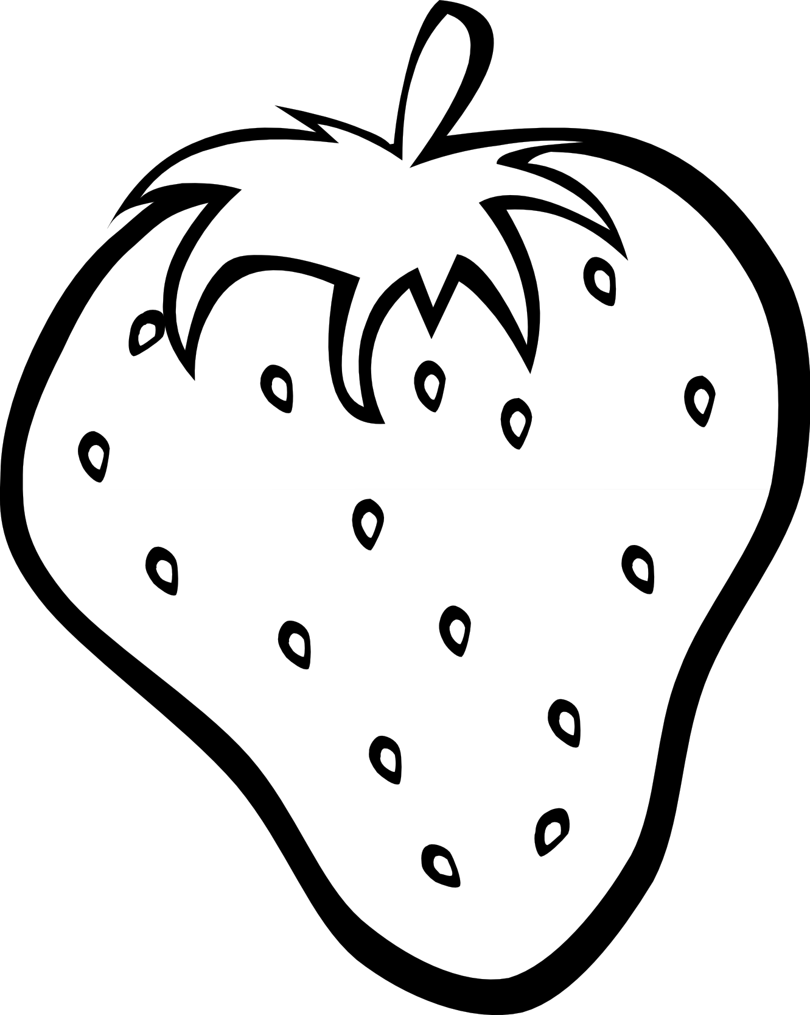 | 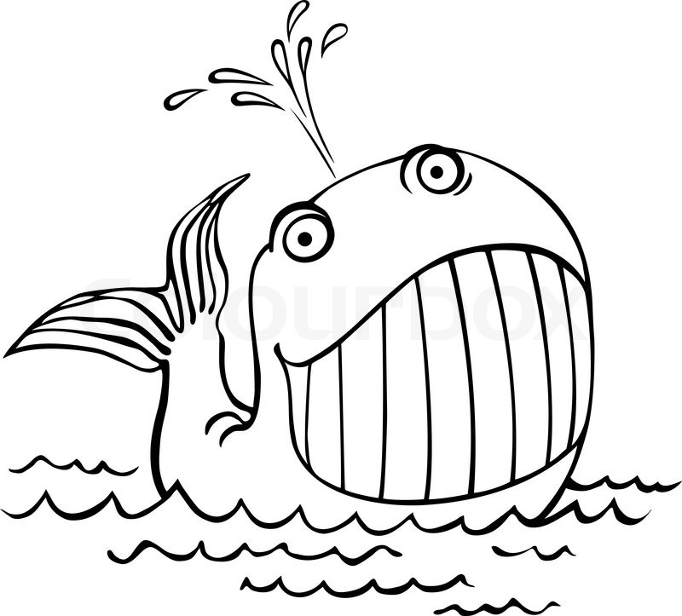 | 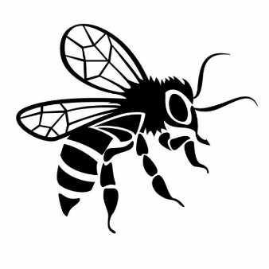 | 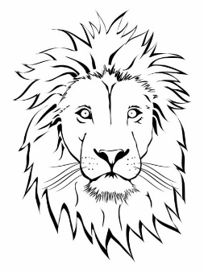
House | Strawberry | Whale | Bee | Lion
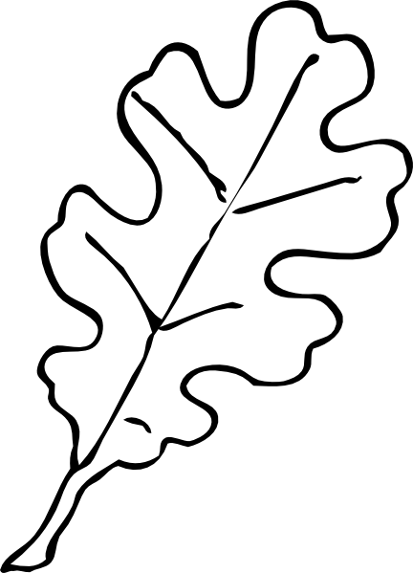 |  | 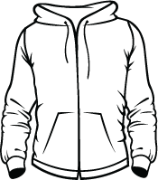 |  | 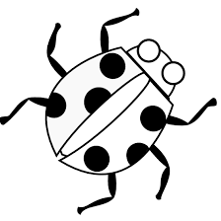
Leaf | Globe | Jacket | Cat | Lady Bug

Were the words easier to remember with the pictures? Give an example of how you can apply visualization to study skills.

