Directions: Use your scores from Measure Your Success to complete this wheel.
Name__________________________________________Date___________________
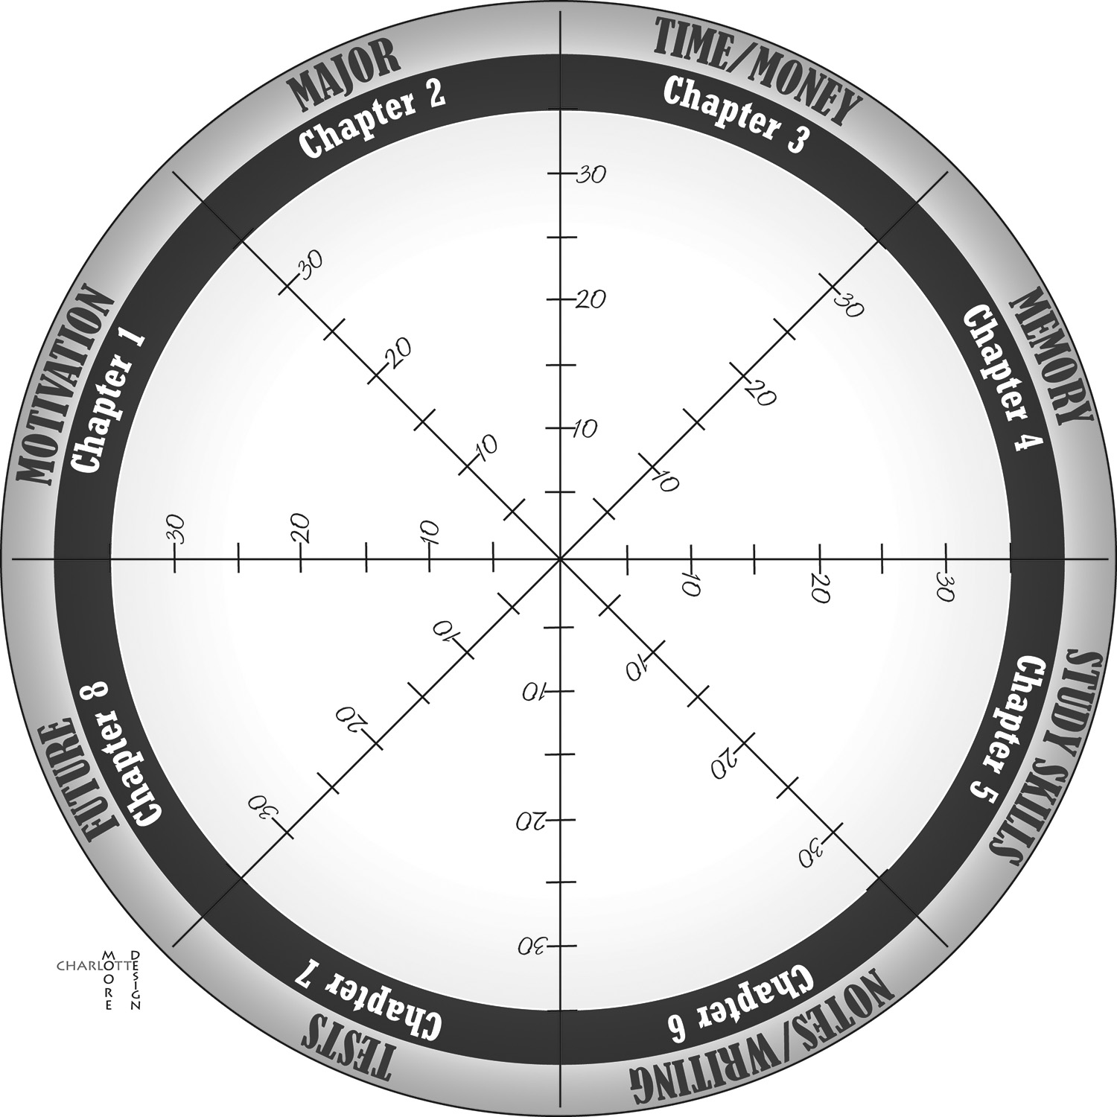
Compare your results to those on this same assessment in Chapter 1. How much did you improve?

